What are micro services? : Micro services are a modern approach to software whereby application code is delivered in small, manageable pieces, independent of others.Loosely coupled. Independently deployable.
Each micro service is focused on single business capability.
It is an architectural development style in which the application is made up of smaller services communicating with each other directly using light weight protocols like HTTP.“Micro-services are the small services that work together.”

Why build micro services? : Their small scale and relative isolation can lead to many additional benefits, such as easier maintenance, improved productivity, greater fault tolerance, better business alignment, and more.

Micro services resilience with Spring Cloud : The distributed nature of micro services brings challenges. Spring helps you mitigate these. With several ready-to-run cloud patterns, Spring Cloud can help with service discovery, load-balancing, circuit-breaking, distributed tracing, and monitoring. It can even act as an API gateway.

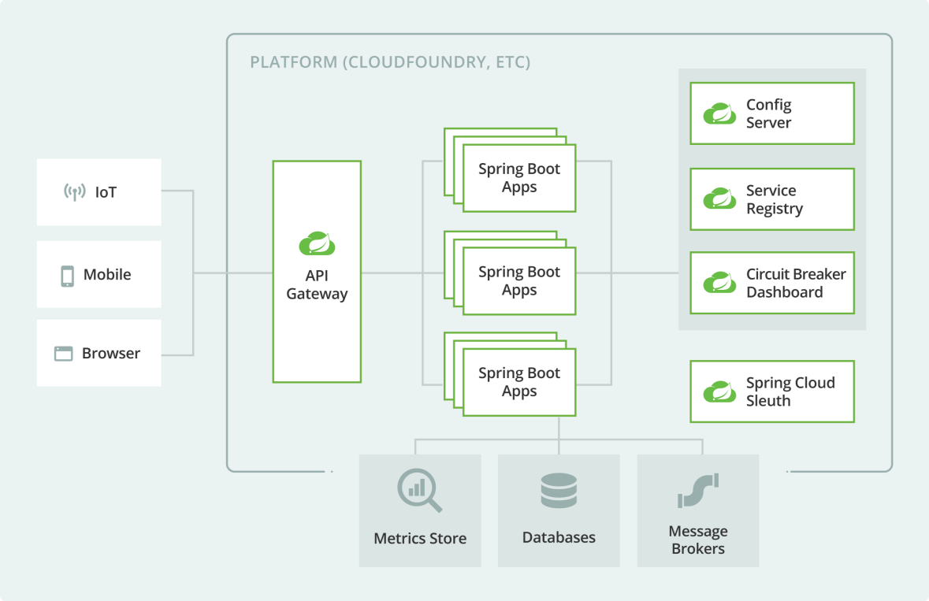

Monolithic vs Microservices architecture :
 | Monolithic | Microservices
Basic | Monolithic architecture is built as one large system and is usually one code-base | Microservices architecture is built as small independent module based on business functionality
Scale | It is not easy to scale based on demand | It is easy to scale based on demand.
Database | It has shared database | Each project and module has their own database
Deployment | Large code base makes IDE slow and build time gets increase. | Each project is independent and small in size. So overall build and development time gets decrease.
Tightly Coupled and Loosely coupled | It extremely difficult to change technology or language or framework because everything is tightly coupled and depend on each other | Easy to change technology or framework because every module and project is independent

Monolithic applications : If all the functionalities of a project exists in a single codebase, then that application is known as monolithic application. We design our application in various layers like presentation, service and persistence and then deploy that codebase as single jar/war file. This is nothing but a monolithic application where “mono” represents the single codebase containing all the required functionalities.
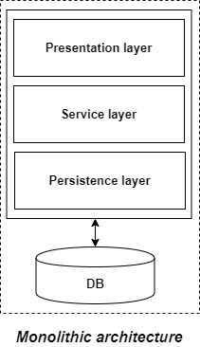

Disadvantages of Monolithic applications:
- It becomes too large in size with time and hence, difficult to manage.
- We need to redeploy the whole application even for a small change.
- As the size of the application increases, its start-up and deployment time also increases.
- For any new developer joining the project, it is very difficult to understand the logic of large Monolithic application even if his responsibility is related to a single functionality.
- Even if a single part of the application is facing a large load/traffic, we need to deploy the instances of the whole application in multiple servers. It is very inefficient and takes up more resources unnecessarily. Hence, horizontal scaling is not feasible in monolithic applications.
- It is very difficult to adopt any new technology which is well suited for a particular functionality as it affects the whole application, both in terms of time and cost.
- It is not very reliable as a single bug in any module can bring down the whole monolithic application.

Advantages of monolithic applications:
- Simple to develop relative to microservices where skilled developers are required in order to identify and develop the services.
- Easier to deploy as only a single jar/war file is deployed.
- Relatively easier and simple to develop in comparison to microservices architecture.
- The problems of network latency and security are relatively less in comparison to microservices architecture.

Principles of microservices:
- Single responsibility: It is one of the principles defined as a part of SOLID design pattern. It states that a single unit, either a class, a method, or a microservice should have one and only one responsibility. Each microservice must have a single responsibility and provide a single functionality. You can also say that: the number of microservices you should develop is equal to the number of functionalities you require. The database is also decentralized and generally, each microservice has its own database.
- Built around business capabilities: In today’s world, where so many technologies exist, there is always a technology which is best suited for implementing a particular functionality. But in monolithic applications, it was a major drawback, as we can’t use different technology for each functionality and hence, need to compromise in particular areas. A microservice shall never restrict itself from adopting appropriate technology stack or backend database storage which is most suitable for solving the business purpose i.e. each micoservice can use different technology based on business requirements.
- Design for failure: Microservices must be designed with failure cases in mind. Microservices must exploit the advantage of this architecture and going down of one microservice should not affect the whole system, other functionalities must remain accessible to the user. But this was not the case in the Monolithic applications, where failure of one module leads to downfall of the whole application.

Advantages of microservices:
- It is easy to manage as it is relatively smaller in size.
- If there’s any update in one of the microservices, then we need to redeploy only that microservice.
- Microservices are self-contained and hence, deployed independently. Their start-up and deployment time are relatively less.
- It is very easy for a new developer to on-board the project as he needs to understand only a particular microservice providing the functionality he will be working on and not the whole system.
- If a particular microservice is facing a large load because of the users using that functionality in excess then we need to scale out that microservice only. Hence, microservices architecture supports horizontal scaling.
- Each microservice can use different technology based on the business requirements.
- If a particular microservice goes down due to some bug, then it doesn’t affect other microservices and the whole system remains intact, continues providing other functionalities to the users.

Disadvantages of microservices:
- Being a distributed system, it is much more complex than the monolothic applications. Its complexity increases with the increase in number of microservices.
- Skilled developers are required to work with microservices architecture which can identify the microservices and manage their inter-communications.
- Independent deployment of microservices is complicated.
- Microservices are costly in terms of network usage as they need to interact with each other and all these remote calls results into network latency.
- Microservices are less secure relative to monolithic applications due to the inter-services communication over the network.
- Debugging is difficult as the control flows over many microservices and to point out why and where exactly the error occurred is a difficult task.

Service oriented architecture (SOA) vs Microservices architecture:
SOA evolved in order to deal with the problems in the monolithic architecture and became popular in the early 2000s. In SOA, the large application is split up into multiple smaller services that are deployed independently. These services doesn’t communicate with each other directly. There used to be an Enterprise Service Bus (ESB, a middleware or server with the help of services using different protocols or message standards can communicate with each other easily) where these services expose themselves and communicate with each other through it. Also, there was no guideline to have independent database for each service.
Microservices architecture is an evolution of SOA. People also consider SOA as a superset of microservices. In simple terms, microservices is fine-grained SOA. Here, the microservices communicates with each other directly and there is no central dependency for communication such as ESB in SOA. Also, there is a guideline to have a separate database for each microservice. The fundamental idea of evolution of microservices from SOA is to reduce the dependency between the services and make them loosely coupled by above mentioned guidelines.

 | Microservices | Service oriented architecture
Architecture | Designed to host services which can function independently | Designed to share resources across services
Component sharing | Typically does not involve component sharing | Frequently involves component sharing
Granularity | Fine-grained services | Larger, more modular services
Data storage | Each service can have an independent data storage | Involves sharing data storage between services
Governance | Requires collaboration between teams | Common governance protocols across teams
Size and scope | Better for smaller and web-based applications | Better for large scale integrations
Communication | Communicates through an API layer | Communicates through an ESB
Coupling and cohesion | Relies on bounded context for coupling | Relies on sharing resources
Remote services | Uses REST and JMS | Uses protocols like SOAP and AMQP
Deployment | Quick and easy deployment | Less flexibility in deployment

service-oriented architecture (SOA) has an enterprise scope, while the microservices architecture has an application scope.

What is microservices components & architecture :
Microservices – also known as the microservice architecture – is an architectural style that structures an application as a collection of services that are. Highly maintainable and testable. Loosely coupled. Independently deployable. Organized around business capabilities.

Why do we need microservices in architecture? : Microservice architecture allows you to maximize deployment velocity and application reliability by helping you move at the speed of the market. Since applications each run in their own containerized environment, applications can be moved anywhere without altering the environment
Here are 8 core components are Microsoft Architecture:
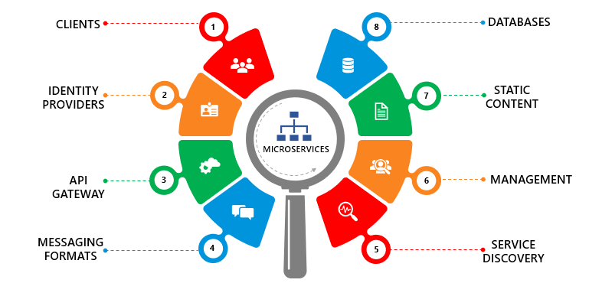
- Clients
- Identity Providers
- API Gateway
- Messaging Formats
- Databases
- Static Content
- Management
- Service Discovery
Clients: The client apps usually need to consume functionality from more than one microservice. The client needs to handle multiple calls to microservice endpoints if that consumption is performed directly. Client apps need to be updated frequently, making the solution harder to evolve.
Identity Providers: The services are fine-grained and lightweight. The Identity Microservice must allow both user-driven and server-to-server access to identity data. Microservices allow applications to be created using a collection of loosely coupled services.
API Gateway: The API Gateway is responsible for request routing, composition, and protocol translation. It provides each of the application’s clients with a custom API. For most microservices-based applications, implementation of an API Gateway is very important for a single-entry point into a system.
Messaging Formats: Synchronize and Asynchronized are the 2 types of messages through which they communicate. Every microservice in order to communicate either synchronously or asynchronously with other microservices. “Synchronous – HTTP is a synchronous protocol. The client sends a request and waits for a response from the service. The client code or message sender usually does not wait for a response.
Databases: Microservice owns a private database to capture their data and implement the respective business functionality. Microservices databases are updated through their service API. The services provided by Microservices are carried forward to any remote service which supports inter-process communication for different technology stacks.
Static Content: After the microservices communicate within themselves, they deploy the static content to a cloud-based storage service that can deliver them directly to the clients via Content Delivery Networks (CDNs).
Management: Management feature is a capability that allows operations and business users to configure services in run-time. For load balancers, the approaches to feature flags management in microservices architecture are a complex topic, especially when one business feature spans multiple microservices.
Service Discovery: In a microservices application, the set of running service instances changes dynamically. Instances have dynamically assigned network locations. Consequently, for a client to make a request to service it must use a service-discovery mechanism. A key part of service discovery is the service registry.
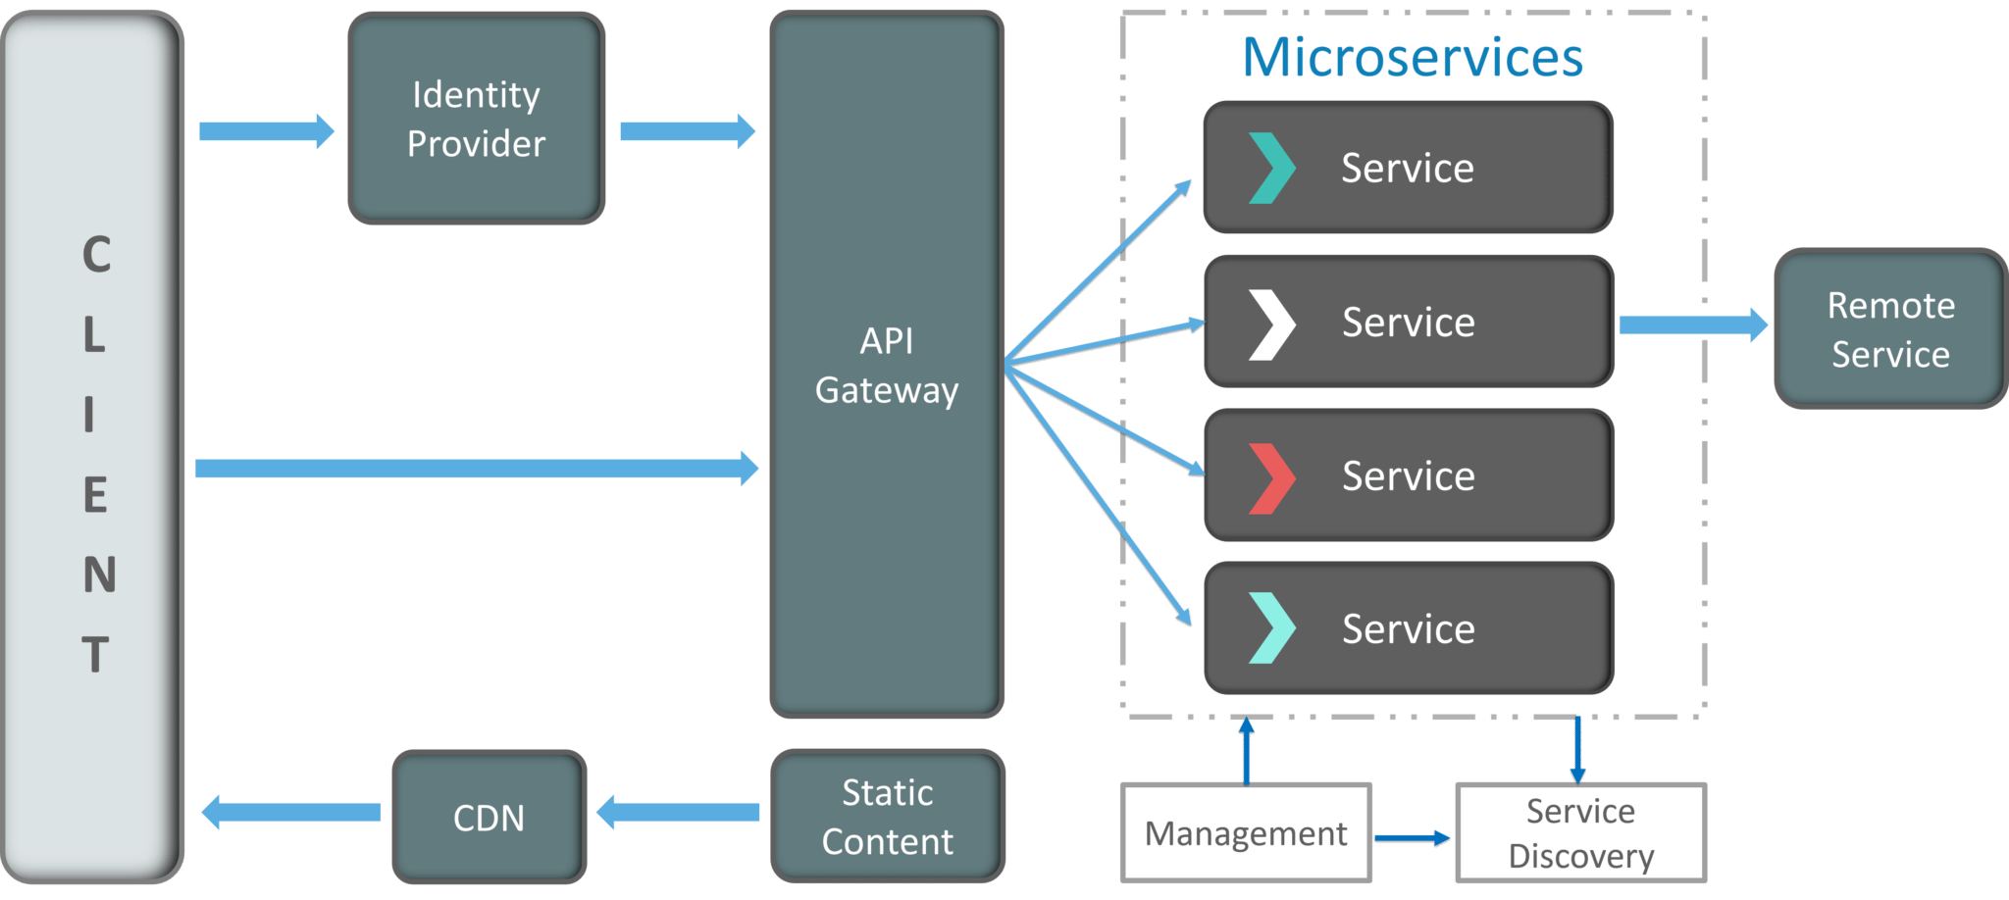

Components of Microservices :There are the following components of microservices:

Spring Cloud Config Server

Netflix Eureka Naming Server

Hystrix Server

Netflix ZuulAPI Gateway Server

Netflix Ribbon

Zipkin Distributed Tracing Server
What is eureka discover service ? : Eureka Server is an application that holds the information about all client-service applications. Every Micro service will register into the Eureka server and Eureka server knows all the client applications running on each port and IP address. Eureka Server is also known as Discovery Server.

Service Discovery is the process of how microservices discover each other over a network. There are two main components of it in terms of Eureka service:

- Eureka server (service registry): It is a server that stores the addresses (host and ports) of all the registered microservices.

- Eureka Client: Its a microservice registered on the central server and it updates and retrieves addresses to/from the central Eureka server.

Eureka provides service discovery in a microservices architecture. This involves two steps on a high level:-

> Services registers themselves on the Eureka server and details like name, host, and port are stored there.

> Details of other registered microservices become available for the registered service.

Eureka Server Setup : 1. Add Required dependencies:

We can see that we have added a dependency for spring-cloud-dependencies in dependency management.

<dependency>
<groupId>org.springframework.cloud</groupId>
<artifactId>spring-cloud-starter-netflix-eureka-server</artifactId>
</dependency>

2.Add @EnableEurekaServer on main Application class (EurekaApplication): The @EnableEurekaServer annotation activates Eureka Server related configuration. It enables the service registry and makes our spring boot application act as a Eureka Server.
3.Add properties in application.properties file:

Now we will add the eureka related properties to our project's application.properties file.

spring.application.name = Eureka
server.port = 5555
eureka.client.fetch-registry = false
eureka.client.register-with-eureka = false
eureka.client.service-url.defaultZone = http://localhost:5555/eureka

In the above properties file:

Firstly we have specified the application name as Eureka.

Then we have specified the port on which the eureka server will run. By default, it is 8761.

Eureka server has a built-in Eureka client also. As in production, generally there is a cluster of Eureka servers and they register among themselves as client. But for learning purposes, we are running the server on the localhost and we don’t need a cluster. So we need to switch off the client's behavior so that it doesn't try to register itself. So the next two properties specify that.

At last, we have specified the service-url which is the URL of itself as there is no other server (standalone mode). If we don't specify this, the Eureka server will still run on the port specified and we will be able to access the UI at the same port but in the below screenshot of UI, the last two URLs under General info will have the default port (8761) and not 5555.

The Eureka server will have its home page with UI at http://localhost:5555/

Eureka Client Setup : 1. Add dependencies in both the microservices:
<dependencies>
<dependency>
<groupId>org.springframework.cloud</groupId>
<artifactId>spring-cloud-starter-netflix-eureka-client</artifactId>
</dependency>

- Add @EnableEurekaClient on main application class (Micro1Application and Micro2Application):

Up to certain versions, adding @EnableEurekaClient annotation was mandatory. But now it is optional and we can skip that if we are having the spring-cloud-starter-netflix-eureka-client dependency in our client microservices.

In order to specifically declare that, we can still specify it so that whenever someone sees our application class, they can immediately know that it is a Eureka Client.
Add following properties in application.properties file:

The first property specify the name of the application. If we don’t specify it, the service will still get registered with the Eureka server but its name will be UNKNOWN.

The second property specifies the port on which the microservice will run. The last property is optional if the Eureka server is running on its default port (8761) otherwise we have to specify it.

Micro1 - application.properties:

spring.application.name = micro1
server.port = 8080
eureka.client.service-url.defaultZone = http://localhost:5555/eureka

Micro2 - application.properties:

spring.application.name = micro2
server.port = 8081
eureka.client.service-url.defaultZone = http://localhost:5555/eureka

Now, when we run our two microservices, we will be able to see them registered on the Eureka server under Instances currently registered with Eureka. By default, Eureka uses the client's heartbeat to determine if a client is up.

Autowire the DiscoveryClient and use it to get the URI of other microservices:
The autowired discovery client is used to get all the instances of the service registered at Eureka server with the name Micro2. From that list of instances, we are fetching the first instance's URI and using it to make the HTTP call.
@Autowired DiscoveryClient discoveryClient;

Setup Multiple Eureka Servers (Cluster) :
We have created only one Eureka server. But what if it goes down? Microservices will not be able to communicate with each other and hence, our server becomes a single point of failure. To avoid that, in production, there's generally a cluster of Eureka servers with 2 or more servers. So let's see how to do that.
Create two Eureka servers with below application.properties:
Eureka server 1 - application.properties:
spring.application.name = Eureka
server.port = 5555
eureka.client.fetch-registry = false
eureka.client.register-with-eureka = false
eureka.client.service-url.defaultZone = http://localhost:5558/eureka
Eureka server 2 - application.properties:
spring.application.name = Eureka2
server.port = 5558
eureka.client.fetch-registry = false
eureka.client.register-with-eureka = false
eureka.client.service-url.defaultZone = http://localhost:5555/eureka
Microservice1 - application.properties:
spring.application.name = micro1
server.port = 8080
eureka.client.service-url.defaultZone = http://localhost:5555/eureka, http://localhost:5558/eureka
Microservice2 - application.properties:
spring.application.name = micro2
server.port = 8081
eureka.client.service-url.defaultZone = http://localhost:5555/eureka, http://localhost:5558/eureka

Some Important notes on Eureka:
- An application registered with Eureka is known as Eureka instance. Every Eureka instance is also a Eureka Client as it can fetch the details of other Eureka instances also.
- If we are using the Eureka server in standalone mode, i.e. there’s only one Eureka server then we need to set eureka.client.fetch-registry and eureka.client.register-with-eureka to false so that it doesn’t try to register itself with itself as the Eureka server also has a built-in Eureka client.
- A service is registered with the Eureka server when the eureka.client.register-with-eureka is set to true (by default, true) and it becomes an Eureka instance. Then this instance keeps sending heartbeats to the Eureka server. If Eureka server doesn’t receive a heartbeat from any instance within a particular time limit (by default, 30 secs) then it will consider that instance as DOWN and will de-register it from the service registry.
- A Eureka instance is also a Eureka client as it fetches the registry from Eureka server containing the details of other instances. In order to enable it, eureka.client.fetch-registry is set to true (by default, true). As soon as a service registers itself with the server, it fetches the registry and catches it. It keeps on checking the registry at regular interval (by default, 30 secs) and if there is any change in the registry, it fetches the update only and the unchanged part is still used from the cache.
- Each Eureka instance uses a service endpoint, DiscoveryClient in order to get a list of all the ServiceInstance instances of the services registered on the registry. We can also see all the registered instances at http://localhost:5555/eureka/apps

Eureka with LoadBalancing : Now, suppose we have 2 instances running the Microservice2 and we want to make our requests load balanced. We will do it by using client-side load balancing.

Zuul API Gateway: will be single point of multiple instance of running Microservice. It will be accepting http request coming from client applcation and then it will routing http request to instance of microservice running behind API gateway. And list of all address running microservice zuul api gateway will get from eureka discovery service.

Zuul Server is an API Gateway application. It handles all the requests and performs the dynamic routing of microservice applications. It works as a front door for all the requests. It is also known as Edge Server.

Zuul provides a range of different types of filters that allows us to quickly and nimbly apply functionality to our edge service. The filters perform the following functions:

- Authentication and Security: It provides authentication requirements for each resource.
- Insights and Monitoring: It tracks meaningful data and statistics that give us an accurate view of production.
- Dynamic Routing: It dynamically routes the requests to different backed clusters as needed.
- Stress Testing: It increases the traffic to a cluster in order to test performance.
- Load Shedding: It allocates capacity for each type of request and drops a request that goes over the limit.
- Static Response Handling: It builds some responses directly at the edge instead of forwarding them to an internal cluster.
- Multi-region Resiliency: It routes requests across AWS regions in order to diversify our ELB usage.

To create a new API Gateway with Netflix Zuul we will first need to create a very simple Spring Boot Web Service.
Add Gateway Starter and Eureka Client dependencies
<dependency>
<groupId>org.springframework.cloud</groupId>
<artifactId>spring-cloud-starter-netflix-eureka-client</artifactId>
</dependency>
<dependency>
<groupId>org.springframework.cloud</groupId>
<artifactId>spring-cloud-starter-netflix-zuul</artifactId>
</dependency>

Zuul API Gateway Application.properties File
- server.port=8011
- spring.application.name=zuul
- eureka.client.serviceUrl.defaultZone = http://localhost:8010/eureka
- eureka.client.fetchRegistry=true
- eureka.client.registerWithEureka=true

Zuul API Gateway Main Application Java File
Next, we need to update the main Application Java file of our Zuul Spring Boot app. Locate in your Zuul project the Java which contains public static void main(String[] args) and add above the class the following two annotations:

@EnableEurekaClient – Zuul API Gateway also needs to register with Eureka Discovery Service
@EnableZuulProxy – this annotation will make our Spring Boot App behave as a Zuul API Gateway.

Although this is a very basic setup of Zuul API Gateway it should work well and you should be able to communicate with your RESTful Web Services via the Gateway. You can also start up more instance of same RESTful Web Services and Zuul will also load balance HTTP Requests between them. More on how to start up more of the same Microservices and see how load balancer works.

Sending HTTP Request : Now when you have your RESTful Web Services registered with Eureka Discovery Server and you have your Zuul API Gateway started, you should be able to send HTTP requests to any of the two web services registered and receive expected HTTP response.

The URL to Users Microservice :
Let’s have a look at how the request URL to our Microservice should look like. Below are the URLs to the two Microservices we have started up in this tutorial and have made them available via the Zuul API Gateway. So the HTTP requests you send to your RESTful Web Services should be now sent via the gateway.

http://localhost:8011/users-ws/users/status/check
http://localhost:8011/albums-ws/users/status/check
where:

- http://localhost – is the protocol and the domain name of your Zuul API Gateway,
- 8011 – the port number you have specified in the application.properties file of your Zuul API Gateway,
- /users-ws and /albums-ws – are the application names you have assigned to your Microservices in the application.properties file. Have a look at the property called “spring.application.name” in the above-mentioned examples of application.properties file of each of the RESTful Web Services,
- /users and the /albums – is the Request Mapping you have in you @RestController class. If you look at the example of Rest Controller call of Users Microservice above, it has a @RequestMapping(“/users”) annotation,
- /status/check – is the method level Request Mapping in the Rest Controller class. For example, @GetMapping(“/status/check”).

Steps :
- Start up Eureka Discovery Server,
- Start up a simple Users Microservice. This can be any other Microservice you have,
- Create, configure and start up a new Zuul API Gateway,
- Send HTTP Requests to a Microservice via Zuul API Gateway.

Zuul and Eureka – Load Balancing Example :
Load balancing Spring Boot Microservices using Netflix’s Ribbon : One of the most prominent reasons of evolution from monolithic to microservices architecture is horizontal scaling. It is required in modern day applications to improve user experience in the case of higher traffic for a particular service. We create multiple instances of the service in order to handle the large traffic of requests. But if the requests are not distributed among the instances effectively, then horizontal scaling is of no use.

Load balancing refers to efficiently distributing the incoming network traffic across a group of backend servers (multiple instances of the service).

Types of load-balancing : Load balancing can be of two types:

- Server-side Load Balancing
- Client-side Load Balancing

Server-side Load Balancing: In Server-side load balancing, the instances of the service are deployed on multiple servers and then a load balancer is put in front of them. It is generally a hardware load balancer. All the incoming requests traffic firstly comes to this load balancer acting as a middle component. It then decides to which server a particular request must be directed to based on some algorithm.

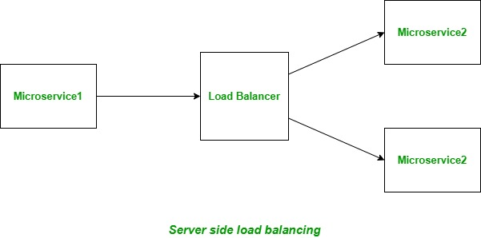

we distribute our user requests.In a Spring Cloud MicroServices ecosystem load balancing is an important and common functionality .

Zuul acts as a gateway for requests from websites, mobile devices to the backend of your service. Zuul is an edge service that provides dynamic routing, monitoring, resiliency, security, and many more features.
Disadvantages of Server-side load balancing
- Server side load balancer acts as a single point of failure as if it fails, all the instances of the microservice becomes inaccessible as only load balancer has the list of servers.
- Since each microservice will have a separate load balancer, the overall complexity of the system increases and it becomes hard to manage.
- The network latency increases as the number of hops for the request increases from one to two with the load balancer, one to the load balancer and then another from load balancer to the microservice.

In Java EE architecture, we deploy our war/ear files into multiple application servers, then we create a pool of server and put a load balancer (Netscaler) in front of it, which has a public IP. The client makes a request using that public IP, and Netscaler decides in which internal application server it forwards the request by round robin or sticky session algorithm. We call it server side load balancing.

Problem: The problem of server side load balancing is if one or more servers stop responding, we have to manually remove those servers from the load balancer by updating the IP table of the load balancer.

Another problem is that we have to implement a failover policy to provide the client with a seamless experience.

But microservices don't use server side load balancing. They use client side load balancing.

Client-side Load Balancing : The instances of the service are deployed on multiple servers. Load balancer's logic is part of the client itself, it holds the list of servers and decides to which server a particular request must be directed to based on some algorithm. These client side load balancers are also known as software load balancers. In 'client side load balancing' the caller of the application (aka the client) handles the load balancing.

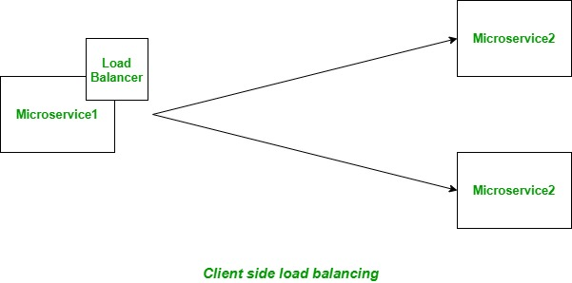

Disadvantages of Client-side load balancing
The load balancer's logic is mixed up with the microservice code.

The client should be aware of all the nodes available in the application cluster. Next, assume that there is a library available to the client, which implements the standard load balancing algorithms.
Now all that the client has to do - is delegate the request to this library and it shall invoke one of the application nodes, based on the chosen load balancing algorithm.

Why Use Client Side Load Balancing? :
- No More Single Point Of Failure In A Cluster: In a cluster fronted by a single load balancer there is always risk if the cluster-nodes becoming unreachable if the load balancer goes down. Remember - failure is a norm, not an exception. With client side load balancing.
- Auto-discovery: With server side load balancers, each new node has to be configured in the load balancer's configuration file. This can be automated using tools like chef, but more often requires load balancer restart or reload for the configuration to take effect. In case the configuration is not automated, it requires manual intervention. Automating it requires another set of skills to master. It is not out of the box. With client side load balancing, the load-balancing library packaged with the application takes care of this aspect. The discovery is totally transparent and all it needs is configuring the IP/hostnames of the registry servers in the application's configuration files.
- One Hop Less (less HTTP hops) : Stating the obvious - each call routed through server side load balancer implies an additional network hop, which in-turn implies additional latency. With client side load balancers, we save this network hop as all inter-service communications are peer-to-peer.

To understand client side load balancing, let's recap microservices architecture. We generally create a service discovery like Eureka or Consul, where each service instance registers when bootstrapped. Eureka server maintains a service registry; it maintains all the instances of the service as a key/value map, where the {service id} of your microservice serves as the key and instances serve as the value. Now, if one microservice wants to communicate with another microservice, it generally looks up the service registry using DiscoveryClient and Eureka server returns all the instances of the calling microservice to the caller service. Then it was a caller service headache which instance it calls. Here, client side load balancing stepped in. Client side load balancing maintains an algorithm like round robin or zone specific, by which it can invoke instances of calling services. The advantage is s service registry always updates itself; if one instance goes down, it removes it from its registry, so when the client side load balancer talks to the Eureka server, it always updates itself, so there is no manual intervention- unlike server side load balancing- to remove an instance.

Another advantage is, as the load balancer is in the client side, you can control its load balancing algorithm programmatically. Ribbon provides this facility, so we will use Ribbon for client side load balancing.

What is Netflix's Ribbon: Netflix's Ribbon is an Inter Process Communication (remote procedure calls) library with built in client side(software) load balancer and is a part of Netflix Open Source Software (Netflix OSS).

Following are the features of Ribbon:

- Load balancing: It provides client side load balancing functionality.
- Fault tolerance: It can be used to determine whether the servers are up or not and can also detect those servers that are down and hence, ignore them for sending the further requests.
- Configurable load balancing rules: By default ribbon uses RoundRobinRule for distributing requests among servers. In addition to it, it also provides AvailabilityFilteringRule and WeightedResponseTimeRule. We can also define our custom rules as per our needs.
- It supports multiple protocols like HTTP, TCP, UDP etc.

Using Ribbon with Java (Spring) Microservice : create two microservices Microservice1 and Microservice2. The Microservice2 will be having its two instances running and Microservice1 will call Microservice2.
Ribbon logic will be included in Microservice1 in order to load balance the requests among the two instances of Microservice2.

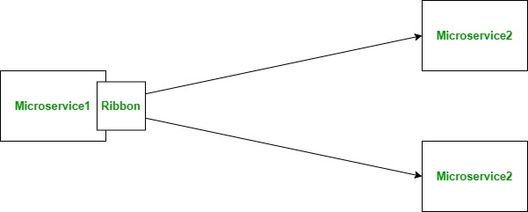

Step 1: Create Microservice2 and run its two instances on ports: 8200 and 8201.

Let's work on creating the Microservice2. Go to Spring Initializr and create a new spring boot application. Add Spring Web dependency and click on Generate. A zip file will be downloaded, extract it. Then open your spring tool suite (STS) and click on File > Import > Maven > Existing Maven Project > Browse and open the project you extracted.

Microservice2 Controller:
import org.springframework.beans.factory.annotation.Value;
import org.springframework.web.bind.annotation.GetMapping;
import org.springframework.web.bind.annotation.RequestMapping;
import org.springframework.web.bind.annotation.RestController;
@RestController
@RequestMapping("/microservice2")
public class Micro2Controller {

@Value("${server.port}")
private String port;

@GetMapping("/port")
public String getPort() {
return port;
}}

Step 2: Create Microservice1 and add Ribbon dependency in its "pom.xml" file. add spring-cloud-starter-netflix-eureka-client dependency
<dependency>
<groupId>org.springframework.cloud</groupId>
<artifactId>spring-cloud-starter-netflix-ribbon</artifactId>
</dependency>

Step 3: Create a Configuration file with @Configuration annotation.
Create a bean of RestTemplate with @Bean and @LoadBalanced annotations. The @LoadBalanced annotation on the RestTemplate indicates that we want it to be load
balanced and it will use RibbonClient to get the list of server addresses.

import org.springframework.cloud.client.loadbalancer.LoadBalanced;
import org.springframework.context.annotation.Bean;
import org.springframework.context.annotation.Configuration;
import org.springframework.web.client.RestTemplate;

@Configuration
public class Micro1Config {

@Bean
@LoadBalanced
public RestTemplate restTemplate() {
return new RestTemplate();
}
}

Step 3: Create a Controller class annotated with @RestController and @RibbonClient(name="micro1")
Autowire the RestTemplate field and use it to call Microservice2 from the controller method. The @RibbonClient annotation is used to customize the Ribbon settings or if we are not using any service discovery then its used to specify the list of servers.

The name we define in the name field of the @RibbonClient annotation is used as a prefix of the ribbon configurations in "application.properties" and as "logical identifier" in the URL we pass to the RestTemplate. The configuration field is used to specify a configuration class that holds all our customizations as @Bean.

@RestController
@RibbonClient(name = "micro1")
public class Micro1Controller {
@Autowired
RestTemplate restTemplate;

@GetMapping("/getmicro2")
public String getMicro2Instance() {
String url = "http://micro1/microservice2/port";
String port = "Currently hitting instance running on port: " +
restTemplate.getForObject(url, String.class);
return port;
}
}

Step 4: Disable Eureka service discovery component
Now we will disable the Eureka service discovery component by setting eureka.enabled = false and add the list of servers in the "application.properties" using named client "micro1".

micro1.ribbon.eureka.enabled = false
micro1.ribbon.listOfServers = localhost:8200, localhost:8201

Step 5: Test the Application
Now let's test our application. Open Postman and hit the URL "http://localhost:8080/getmicro2" 4 times:

You should get the following response:
Currently hitting instance running on port: 8200
Currently hitting instance running on port: 8201
Currently hitting instance running on port: 8200
Currently hitting instance running on port: 8201

The requests are being load-balanced among the two instances of Microsevice2 in RoundRobin fashion. We have used Ribbon as a client-side load balancer for load balancing the traffic for our Spring Boot application.

how to use Zuul API Gateway to enable the load balancing of your RESTful Web Services registered with Eureka Discovery Service.
Zuul API Gateway internally uses Ribbon Load Balancer there is almost nothing you need to do to have this load balancer work for you.

> Start up Eureka Discovery Service,
> Register Microservices with Eureka Discovery Service,
> Start up Zuul API Gateway.
you have done the above 3 steps and you can send HTTP Requests to your Microservice via the Zuul API Gateway.

Load balancer balances HTTP requests between multiple instances of your Web Service running on different port numbers.For you to be able to see that the load balancer works and that HTTP requests are being load-balanced between multiple instances of your Web Service,

Update the Rest Controller of my application to print our the port number it is running on.

@RestController
@RequestMapping("/users")
public class UsersController {
@Autowired
private Environment env;
@GetMapping("/status/check")
public String status() {
return "Working on port " + env.getProperty("local.server.port");
}
}
When HTTP Get request is sent to a /users/status/check I should see “Working on port 8099” printed in the browser.

To see how load balancer works we need to have at least 2 instances of the same Microservice running. Each instance should run on its own port number. If you have one instance of a Microservice running, then let’s start up one more instance.

When starting up a new instance of a Microservice you need to make sure that it runs on a different port number.
Once you start a new instance of a Microservice, refresh the Eureka Discovery Server page and you should see that the AMIs counter for a registered application has increased. On the picture below you see that my USERS-WS Microservice has now 2 AMIs running. If I start one more instance of USERS-WS Microservice on a different port, the AMIs counter will increase again.

How Load Balancer Works : If you started more than one Microservice and on the Eureka Discovery page you see that the counter of running AMIs is more than 1, you should be ready to send HTTP request to your Microservice and see the port number printed. Make sure you send HTTP Requests via Zuul API Gateway. Send multiple(5 or 6) HTTP requests in a row and you should see a different port number used almost every time. If a different port number is printed, then this means that HTTP requests are being load-balanced between different instances of your Microservice.

Multiple Instances and an Instance Id : If you used server.port=0 to assign a random port number to a Microservice then you might have also noticed that when starting multiple instances of the same Microservice, all HTTP requests are routed to the same port number which is 0. This is because the random port number is being assigned to a Microservice already after it has registered with Eureka. Because of it, every instance of a Microservice you start with the same name and same server.port=0 , simply overrides a previous registration. To resolve this issue, add the following property to your application.properties file so that each instance of a Microservice that starts up has a unique instance ID.
eureka.instance.instance-id=${spring.application.name}:${spring.application.instance_id:${random.value}}

Below is a complete application.properties file which enables a random port number assignment and also a unique instance id value being assigned to each of the instances of a Microservice.

Complete Application Properties File

server.port=${PORT:0}
spring.application.name=users-ws
eureka.client.serviceUrl.defaultZone = http://localhost:8010/eureka
spring.devtools.restart.enabled = true
eureka.instance.instance-id=${spring.application.name}:${spring.application.instance_id:${random.value}}

Once Zuul receives a request for a particular service , it internally uses Netflix Ribbon to lookup for services available from Eureka Service Discovery.

What Is Fault Tolerance? : Fault tolerance is the property that enables a system to continue operating properly in the event of the failure of some of its components. a component means anything: microservice, database(DB), load balancer(LB).

Why do we need this? Microservices depend on other services in order to fulfill their requirements. Since microservices are deployed independently, their instances may go up and down frequently. When the number of interactions between microservices increases, the more likely a failure in a service is to cause a severe impact in the system.

By introducing fault tolerance capabilities, an application is able to operate at a certain degree of satisfaction when failures appear. Failures in a system make a proportional effect in the operation of the application: The more severe a failure is, the more it affects the application. Without fault tolerance, a single failure in the system may cause a total breakdown.

How does it work? : Fault tolerance can be achieved with the help of a circuit breaker pattern that wraps requests to external services and detects when they are faulty. When a failure is detected, the circuit breaker “opens”, and instead of keep making requests to the unhealthy service, all subsequent requests immediately return an error. This reduces the load in the unhealthy service, and prevents resource exhaustion in the client.

Additionally to the circuit breaker, fallback mechanisms are used to fail gracefully when external services are not available. By incorporating fallback mechanisms, you increase resiliency in applications, which usually have views or screens where the failing service is not needed. These views or screens should remain usable despite the external failure.

Fault tolerance can be achieved with the help of a circuit breaker. It is a pattern that wraps requests to external services and detects when they fail. If a failure is detected, the circuit breaker opens. All the subsequent requests immediately return an error instead of making requests to the unhealthy service. It monitors and detects the service which is down and misbehaves with other services. It rejects calls until it becomes healthy again.

Hystrix is a library that controls the interaction between microservices to provide latency and fault tolerance. Additionally, it makes sense to modify the UI to let the user know that something might not have worked as expected or would take more time.

Implementing Fault Tolerance with Hystrix :

Step 1: Open the pom.xml file of limits-service and add the Hystrix dependency
<dependency>
<groupId>org.springframework.cloud</groupId>
<artifactId>spring-cloud-starter-netflix-hystrix</artifactId>
</dependency>
Step 2: Open LimitsServicesApplication.java file and enable Hystrix by using the annotation @EnableHystrix.

Step 3: Open the LimitsConfigurationController.java file and create a Get method.

@GetMapping("/fault-tolerance-example")
//configuring a fallback method
@HystrixCommand(fallbackMethod="fallbackRetrieveConfigurations")
public LimitConfiguration retrieveConfigurations()
{
throw new RuntimeException("Not Available");
}
//defining the fallback method
public LimitConfiguration fallbackRetrieveConfigurations()
{
//returning the default configuration
return new LimitConfiguration(999, 9);
}
Let’s understand what is happening in the above method.

In the above method, we have created a Get mapping for fault tolerance. In the next line, we have used an annotation @HystrixCommand to configure the fallback method. We have defined a method with the name fallbackRetrieveConfigurations() that returns the default value if any fault occurs.

Fallback method : The fallback method is a method that invokes when a fault occurs. Hystrix allows us to define a fallback method for each service method. Here one question arises that if the method throws an exception, what should be returned to the consumer?

So answer is that if retrieveConfiguraions() fails, the method fallbackRetrieveConfigurations() is called. The fallback method returns the hardcoded LimitConfiguration instance.

Step 4: Open the browser and invoke the URL http://localhost:8080/fault-tolerance-example. It returns the values that we have returned in the fallbackRetrieveConfigurations() method.

We can implement a fallback class that we can use when the web service is down:

Implementing a fallback service
Start by specifying a fallback implementation using the @FeignClient annotation:

@FeignClient(value = "${biz-application.name:null}",
url = "${biz-application.url:}",
fallback = CompanyServiceFallback.class)
@Primary
public interface CompanyService { ... }
Use the @Primary annotation to declare the type of bean to inject by default in another bean . You also have to enable Hystrix in a configuration file as follows:

feign.hystrix.enabled: true

Hystrix is a library to control the interaction between services to provide latency and fault tolerance.

Fault tolerance : is the property that enables a system to continue operating properly in the event of the failure of some of its components.
For us, a component means anything: microservice, database(DB), load balancer(LB), you name it.

Identify Failure Scenarios:
- Service A is not able to communicate with Service B.
- Database is not accessible.
- Your application is not able to connect to the file system.
- Server is down or not responding.
- Inject faults/delays into the services.

Design Patterns to Ensure Service Resiliency:
- Asynchronous communication
- Timeouts
- Retries
- Circuit Breaker
- Fallback
- Rate limiters

Understand CircuitBreaker Design pattern with simple practical example:

Problem Statement
We have a serviceA which has two APIs
- /data which depends on serviceB
- /data2 does not depend on any external service

What is circuit breaker design?
- Once serviceA “knows” that serviceB is down, there is no need to make request to serviceB. serviceA should return cached data or timeout error as soon as it can. This is the OPEN state of the circuit
- Once serviceA “knows” that serviceB is up, we can CLOSE the circuit so that request can be made to serviceB again.
- Periodically make fresh calls to serviceB to see if it is successfully returning the result. This state is HALF-OPEN.

Example : Consider a situation where A tries to send a request and B is unavailable for some reason. 1, 2, 3 are the number of retires the gateway performs if the request is not served. Meanwhile, another request is sent from A, that request is retired from 3 times again.
At this point, sending more requests to B will make things even worse. Some way we have to control this situation and move forward. What if there is a chance to get a successful response from B if even in failure condition. Sound good isn’t it? Here comes the circuit breaker design pattern.

Implementation with Circuit Breaker :
Let’s implement a circuitBreaker which makes GET http calls. We need three parameters for our simple circuitBreaker
How many failures should happen before we OPEN the circuit.
What is the time period after which we should retry the failed service once the circuit is in OPEN state?
In our case, the timeout for the API request.

Microservice communication : In the Microservice architecture pattern, a distributed system is running on several different machines, and each service is a component or process of an enterprise application. That means these services at the multiple machines must handle requests from the clients of this enterprise application. Sometimes all these services collaborate to handle those requests. So all services interact using an inter-service communication mechanism.
But in case of the Monolithic application, all components are the part of the same application and run on the same machine. So, Monolithic application doesn’t require microservices inter-service communication mechanism.
Let’s see the following diagram about the microservices inter-service communication between service components of an application:

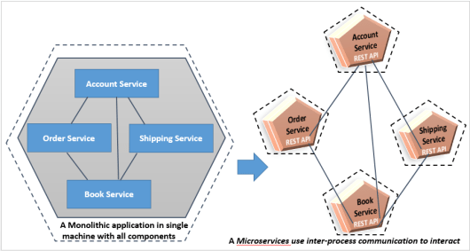

a monolithic application has all of its components combined as a single artifact and deployed to a single machine. One component calls another using language-level method calls.
However, in the microservice architecture, all components of the application run on multiple machines as a process or service and they use inter-process communication to interact with each other.
In Microservice Architecture, we can classify our inter-service communication into two approaches like the following:
- Synchronous communication style
- Asynchronous communication style

Synchronous communication style : In this communication style, the client service expects a response within time and wait for a response by blocking a while.
This style can be used by simple using HTTP protocol usually via REST. It is the simplest possible solution for microservices inter-service communication to interact with services. The client can make a REST call to interact with other services. The client sends a request to the server and waits for a response from the service (Mostly JSON over HTTP).
For example, Spring Cloud Netflix provides the most common pattern for synchronous REST communication such as Feign or Hystrix.

Order-Service calls Book-Service and waits for a response returned by Book-Service. Order-Service can then process Book-Service’s response in the same transaction that triggered the communication.

The synchronous communication approach does have some drawbacks, such as timeouts and strong coupling. For example, the Order Service needs to wait for the response from the Book Service, and the strong coupling means that the Order Service can’t work without the Book Service is available. We can avoid this coupling by using the Hystrix library, which enables us to use fallbacks in case the service is not available at that time.

There are numerous protocols, such as REST, gRPC, and Apache Thrift, that can be used to interact with services synchronously.

Most synchronous communications are one-to-one. In synchronous one-to-one communication, you can also use multiple instances of a service to scale the service. However, if you do, you have to use a load-balancing mechanism on the client side. Each service contains meta-information about all instances of the calling service. This information is provided by the service discovery server, an example of which is Netflix Eureka.

There are several load-balancing mechanisms you can use. One of these is Netflix Ribbon, which carries out load-balancing on the client side
we have multiple instances of a particular service, but the services are still communicating one-to-one. That means that each service communicates to an instance of another service. The load balancer chooses which method should be called. The following is a list of some of the most common load-balancing methods available:

- Round-Robin: This is the simplest method that routes requests across all the instances sequentially.
- Least Connections: This is a method in which the request goes to the instance that has the fewest number of connections at the time.
- Weighted Round-Robin: This is an algorithm that assigns a weight to each instance and forwards the connection according to this weight.
- IP Hash: This is a method that generates a unique hash key from the source IP address and determines which instance receives the request.
You can use the Spring Cloud, it provides support to Netflix libraries to balance the load on the client side; you can also use Spring’s RestTemplate or Feign client. Netflix Feign implements load-balancing internally.

@FeignClient(value = "ACCOUNT-SERVICE", fallback = AccountFallback.class)
public interface AccountClient {
@GetMapping("/accounts/customer/{customerId}")
List getAccounts(@PathVariable("customerId") Integer
customerId);
}
@Component
public class AccountFallback implements AccountClient {
@Override
public List getAccounts(Integer customerId) {
List acc = new ArrayList<>();
return acc;
}
}

Asynchronous communication style : In this communication style, the client service doesn’t wait for the response coming from another service. So, the client doesn’t block a thread while it is waiting for a response from the server. Such type of communications is possible by using lightweight messaging brokers.
The message producer service doesn’t wait for a response. It just generates a message and sends message to the broker, it waits for the only acknowledgement from the message broker to know the message has been received by a message broker or not.

the Order Service generates a message to A Message Broker and then forgets about it. The Book Service that subscribes to a topic is fed with all the messages belonging to that topic. The services don’t need to know each other at all, they just need to know that messages of a certain type exist with a certain payload.

There are various tools to support lightweight messaging, you just choose one of the following message brokers that is delivering your messages to consumers running on respective microservices:

- RabbitMQ
- Apache Kafka
- Apache ActiveMQ
- NSQ
The above tools are based on the AMQP (Advanced Message Queuing Protocol). This protocol provides messaging based inter-service communication. Spring Cloud Stream also provides mechanisms for building message-driven microservices using either the RabbitMQ or the Apache Kafka.

asynchronous communication style; they are as follows:
- Asynchronous one-to-one communication style
- Asynchronous one-to-many communication style
Asynchronous one-to-one communication style : In this communication approach, each request of a service client is processed by one instance of a service. There are the following kinds of one-to-one interactions:

- Notification: In this case, a Client sends a request to the Service; the Client does not wait for a reply from that Service.
- Request/async response: Here, a Client sends a request to a Service, which replies asynchronously; the client does not block the thread while waiting and it is designed with the assumption that the response may not immediately arrive
The following diagram demonstrates one-to-one asynchronous service communication:
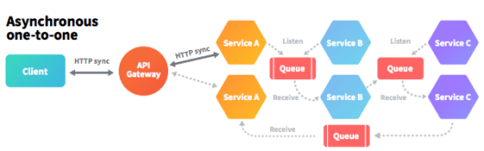

each service has only one instance and the services are communicating through the message broker queue.

Asynchronous one-to-many communication style : In this communication approach, each request of a service client is processed by multiple service instances. There are the following kinds of one-to-many interactions:
- Publish/subscribe: In this approach, a Client publishes a notification message to the message broker and this notification message is consumed by zero or more interesting services.
- Publish/async responses: In this approach, a Client publishes a request message and then waits for a certain amount of time for responses from interested services
Take a look at the following diagram, which demonstrates one-to-many asynchronous service communication:
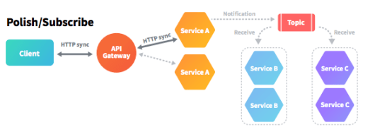
you can see that there are multiple instances of each service. Here, a client service publishes a notification message as a topic and this topic is consumed by one or more instances of the interested services.

https://www.springboottutorial.com/asynchronous-communication-with-queues-in-microservices

https://blog.logrocket.com/methods-for-microservice-communication/

How to register the eureka services? Microservices — Service Registration and Discovery with Netflix Eureka:

Netflix Eureka is a lookup server (also called a registry). All micro-services (Eureka clients) in the cluster register themselves to this server.There are other service discovery clients like Consul, Zookeeper etc, but we will be using Eureka in this article.

Implementation :
1) Create the eureka server project
Create a spring boot application including the below dependency to the pom.xml

<dependency>
<groupId>org.springframework.cloud</groupId>
<artifactId>spring-cloud-starter-netflix-eureka-server</artifactId>
<version>2.1.1.RELEASE</version>
</dependency>

2) Add spring cloud eureka support
To make our server an Eureka Server @EnableEurekaServer annotation is added.

@EnableEurekaServer
@SpringBootApplication
public class SpringEurekaServerApplication {
public static void main(String[] args) {
SpringApplication.run(SpringEurekaServerApplication.class, args);
}
}

3) Configure application.properties / application.yml
Update the below configurations in the server application
server:
# Server port is set to 8761
port: 8761
client:
# Server doesnot required to register it self hence set to false
registerWithEureka: false
# Server Does not required to fetch the registry it self
fetchRegistry: false
serviceUrl:
# Server url is set to below
defaultZone: http://localhost:8761
When you hit the url : http://localhost:8761 then you will get eureka dashboard .

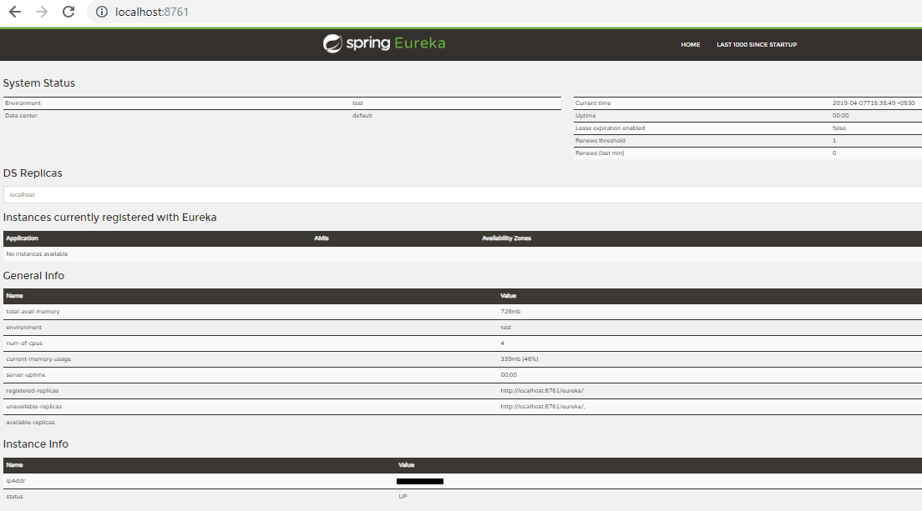

5) Create the eureka client project
Create a spring boot application including the below changes to the pom.xml

<dependency>
<groupId>org.springframework.cloud</groupId>
<artifactId>spring-cloud-starter-netflix-eureka-client</artifactId>
<version>2.1.1.RELEASE</version>
</dependency>

6) Create rest endpoint to retrieve client details from service registry
In order to make sure that we have a eureka client application,@EnableDiscoveryClient annotation is required. Spring will enable service discovery related functionality based on the annotation.

@EnableDiscoveryClient
@SpringBootApplication
public class SpringEurekaClientApplication {
public static void main(String[] args) {
SpringApplication.run(SpringEurekaClientApplication.class, args);
}
}
@RestController
class EurekaClientRestController {
@Autowired
private DiscoveryClient discoveryClient;

@RequestMapping("/clients/{applicationName}")
public @ResponseBody String getClientsByApplicationName(@PathVariable String applicationName) {
return this.discoveryClient.getInstances(applicationName).get(0).getUri().toString();
}
}
The above restful API is exposed to return the connected clients endpoint details from service registry based on the application name given.

7) Configure bootstrap.properties / bootstrap.yml
Update the below configurations in the client application
spring:
application:
name: discovery-client
server:
port: 8383
eureka:
client:
serviceUrl:
defaultZone: http://localhost:8761/eureka/

Or in properties file:

Spring.application.name : discovery-client
Server.port : 8383
Eureka.client.serviceUrl.defaultZone :http://localhost:8761/eureka/

8) Start the eureka client
Start the spring boot application. highlighted in below can be seen, once the client is successfully registered in eureka server.

Also, refresh the eureka dash board to see the updated clients.
Below URL

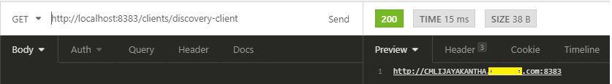

What is config server? : Config Server is an externalized application configuration service. It is based on the open-source Spring Cloud Config project, which provides a centralized server for delivering external configuration properties to an application and a central source for managing this configuration across deployment environments.

With microservices, we create a central config server where all configurable parameters of micro-services are written version controlled. The benefit of a central config server is that if we change a property for a microservice, it can reflect that on the fly without redeploying the microservice.

Create a Spring Cloud Config Server : First, you will create a Spring Boot application that behaves as the configuration server. This application will provide configuration settings to your microservices.

Add Config server dependency into pom.xml

Open the project in your IDE and update src/main/resources/application.properties with the following key-value pairs:

server.port=8888
spring.cloud.config.server.native.search-locations=/path/to/config/folder
spring.security.user.name=configUser
spring.security.user.password=configPass

The property spring.cloud.config.server.native.search-locations is the location where you store your configuration files. Replace the value with a folder on your filesystem where these files will be saved. For example, file://${user.home}/config.

Open your application’s main class and add the @EnableConfigServer annotation:

import org.springframework.cloud.config.server.EnableConfigServer;

@EnableConfigServer
@SpringBootApplication
public class CloudConfigServerApplication { ... }

Let’s take a moment to discuss the naming convention for the configuration files. The filenames are important and must be in a certain pattern for your microservices to pick them up:

/{application}/{profile}[/{label}]
/{application}-{profile}.yml
/{label}/{application}-{profile}.yml
/{application}-{profile}.properties
/{label}/{application}-{profile}.properties

Where:

{application} is the name of your microservice specified via your microservice’s spring.application.name property. In this case, service-one and service-two.
{profile} matches the list of profiles your microservice is running via the spring.profiles.active property. In this case, profile1 and profile2.
{label} is an additional descriptor usually corresponding to a version control branch, e.g. dev or stg. It can be manually set via the spring.cloud.config.label property in the microservice’s bootstrap.properties file or set on the command line (-Dspring.cloud.config.label).

one set for Service One (service-one.yml) and one for Service Two (service-two.yml).

The native profile tells the application to server configuration files from the filesystem directory

Create Spring Boot Microservice #1 :
Select the following dependencies:
- Spring Web
- Config Client
- Spring Boot Actuator

Open the project in your IDE and update src/main/resources/application.properties with the following key-value pairs:

spring.application.name=service-one
spring.config.import=configserver:
spring.cloud.config.uri=http://localhost:8888
spring.cloud.config.username=configUser
spring.cloud.config.password=configPass

spring.application.name is the name of this microservice and must match the {application} parameter in the filename convention described above.
spring.cloud.config.uri is the location of the config server currently running.
spring.cloud.config.username and spring.cloud.config.password are used by your microservice to authenticate with the config server while retrieving configuration files. The values must match the values of spring.security.user.name and spring.security.user.password defined in your config server’s application.properties.

Refresh the Configuration in Your Spring Cloud Config Server : @RefreshScope use this annotation in Controller class

Next, add a security class inside your main application class to secure the endpoint with basic authentication:

@Configuration
public static class ActuatorSecurityConfig extends WebSecurityConfigurerAdapter {
@Override
public void configure(HttpSecurity http) throws Exception {
http
.csrf().disable()
.antMatcher("/actuator/*")
.authorizeRequests()
.antMatchers("/actuator/*").authenticated()
.and()
.httpBasic();
}

@Override
protected void configure(AuthenticationManagerBuilder auth) throws Exception {
auth.inMemoryAuthentication()
.withUser("serviceOneUser")
.password("{noop}serviceOnePassword")
.roles("USER");
}
}

Introducing Centralized Configuration : Centralized configuration is a pattern where the configuration for all services is managed in a central repository rather than being scattered across individual services. Each service pulls its configuration from the central repository on startup.

Spring provides a basis for implementing this pattern via Spring Cloud Config, a subproject of Spring Cloud. With Spring Cloud Config you can create a Spring Boot application that exposes application properties via a REST API. Services can consume their application properties from the REST API rather than loading them locally from the file system or classpath. Configuration is not stored in the Cloud Config Server itself but pulled from a Git repository. This allows you to manage your application configuration with all the benefits of version control. Spring Cloud Config can be configured to use either a local git repository (useful during dev) or a remote repository. In a production environment, you'd want the Config Server to access configuration from a private Git repository.

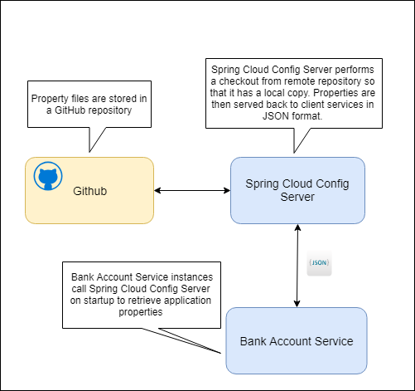

Creating the Cloud Config Service
We'll begin by creating a simple Spring Boot app for the Config Service. Inside the main application class use @EnableConfigServer to enable the config server functionality.

Configuring the POM : In order to make the required Spring Cloud dependencies available you'll need to add the following dependencies to the POM.
<dependency>
<groupId>org.springframework.cloud</groupId>
<artifactId>spring-cloud-config-server</artifactId>
</dependency>
Configuring the Config Server
Next, you'll need to configure the Config Service via the application.properties file.

spring.application.name=config-server
server.port=8888
# URI of GIT repo containing properties
spring.cloud.config.server.git.uri=https://github.com/briansjavablog/micro-services-spring-cloud-config
# path to properties from root of repo
spring.cloud.config.server.git.searchPaths: configuration
logging.level.org.springframework.web=INFO

- Line 1 - spring.application.name specifies the name of the application. This isn't essential but it's good practice to name your Boot applications. This name will appear on the actuator/info endpoint and will be displayed in Spring Boot Admin if you use it.
- Line 2 - server.port specifies the port that the admin app will run on.
- Line 5 - spring.cloud.config.server.git.uri specifies the URL of the remote repository containing the property files that will be served up by the Config Service. In this example, I am pointing at my own repository on GitHub, but this could also point to a local Git repo. A local repository is useful during development and can be specified with the file prefix as follows file:///c:/dev/micor-services/git-local-config-repo.
- Line 8 - spring.cloud.config.server.git.searchPaths specifies the path to the properties files from the root of the repository. So, in the example above, I want to access property files in the configuration directory of the repository.

The profiles attribute is the Spring profile specified in the request. In this instance, we used the default profile, but we can specify any valid profile we want here. If you look at the property files on GitHub you'll see three files.

- bank-account-service.properties - this file contains the default properties and is used as the property source when the default profile is specified on the request.
- bank-account-service-dev.properties - this file has a '-dev' postfix and contains the properties returned when the dev profile is specified on the request.
- bank-account-service-uat.properties - this file has a '-uat' postfix and contains the properties returned when the uat profile is specified on the request.

If we specify dev or uat as the profile, the Config Service will return properties from the file matching that profile.

Example - Bank Account Service Local Configuration
We're going to use the Config Service to retrieve the Bank Account Service configuration. There are however a few properties which must be set locally.

spring.application.name=bank-account-service
server.port=8080
spring.config.cloud.uri=htp://localhost:8888
spring.cloud.config.profile=uat
management.endpoints.web.exposure.include=*

What is ZUUL API gateway in Microservices?
Zuul Server is an API Gateway application. It handles all the requests and performs the dynamic routing of microservice applications. It works as a front door for all the requests. It is also known as Edge Server. Zuul is built to enable dynamic routing, monitoring, resiliency, and security.

How does ZUUL API gateway work?
Zuul acts as an API gateway or Edge service. It receives all the requests coming from the UI and then delegates the requests to internal microservices. ... The client calls this service as a proxy for an internal microservice, then this service delegates the request to the appropriate service.

